H.T No
Regulations:
A17


Sreenidhi Institute of Science and Technology
(An Autonomous Institution)
Code No: 6B412 Date: 30-Jan-2020 (FN)

B.Tech II-Year II-Semester External Examination, Jan/Feb - 2020 (Supplementary)
MACHINE DRAWING AND COMPUTER AIDED DRAWING (ME)

Time: 3 Hours Max.Marks:75

Note: a) No additional answer sheets will be provided.
b) All sub-parts of a question must be answered at one place only, otherwise it will not be valued.
c) Missing data can be assumed suitably.

Part - A Max.Marks:30

ANSWER ANY TWO QUESTIONS. EACH QUESTION CARRIES 15 MARKS.

1. | Draw the three views of a hexagonal headed bolt of 20 mm diameter and 100 mm length, with a hexagonal nut and washer. | [15M]
2. | Draw the front view and side view of a flange coupling for shaft diameter of 25 mm. | [15M]
3. | Draw the sectional front view and top view of a Knuckle Joint with suitable proportions. | [15M]

Part – B Max.Marks:45
Part-B (is Compulsory 45 Marks)

4. | Assemble all parts of the Cross Head given in figure. Draw a) Half sectional front view b) Top View  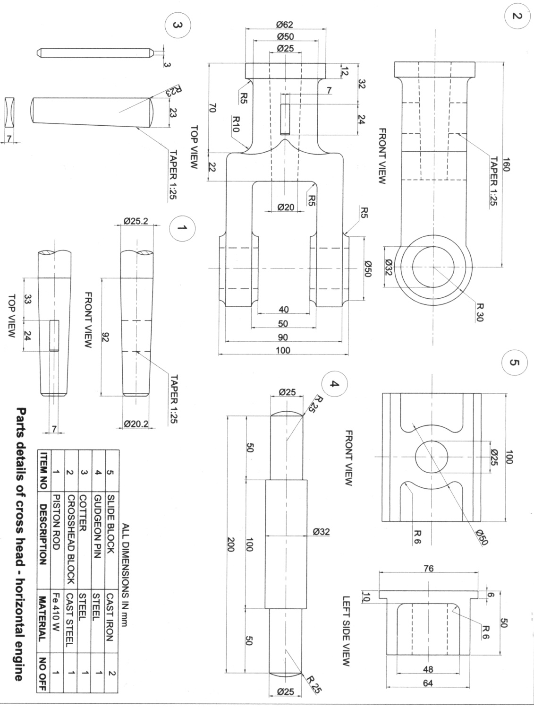 | [40M]

-- 00 -- 00 –

